**Project Title** : ONLINE JEWELLERY SYSTEM

**Technology** : Java

**ONLINE JEWELLERY SYSTEM**

**T.Y.BSC (Computer Science) 2022-23**

**ACKNOWLEDGEMENT**

We are very grateful to present the project report on **“Online Jewellery system”** we would like to express our explicit thanks & acknowledgement to our project guides for their kindly & timely guidance.

We are very grateful to all the faculty members from Computer Science Department especially **Mrs.Gouri Vaidya and Mrs. Ashwini Shivane** for giving us valuable advice, time and suggestions as far as project is concerned. However, it would not have been a success without the support of some of our seniors whom we owe a vote of thanks.

A special thanks to Mr.( Janardhan Pawar, Computer Science Department) for his help and providing us ample IT Services.

We wish to record our appreciation to all our friends and others who helped us throughout the project work directly or indirectly.

**Index –**

|  |  |
| --- | --- |
| **Content Page No** | |
| **Heading page** | **1** |
| **Acknowlegement** | **2** |
| 1. **Introduction of the system**  * **Problem Definition** * **Scope of the system** * **Advantages & Disadvantages of the system** | **4** |
| 1. **System Analysis**  * **Requirement analysis** * **H/W and S/W Requirement** * **Feasibility Study(Operational,** * **Economical, Technical)** * **ER Diagram** * **Data Dictionary** | **5-10** |
| 1. **System Model**  * **Use Case Diagram** * **Class Diagram** * **Activity Diagram** * **Sequence Diagram** * **Collaboration Diagram** * **Deployment Diagram** * **Component Diagram** | **11-17** |
| 1. **User Manual** |  |
| * + **Operational Instructions**   + **Input Screens**   + **Output Screens**   + **Reports** | **18-34** |
| 1. **Testing**  * **Test Techniques Used** * **Test Cases** | **35-37** |
| 1. **Future Enhancement** | **37** |
| 1. **Conclusion** | **37** |
| 1. **Bibliography** | **37** |

Problem Definition:

* As the current system is totally manual. Jewellery shop has a manual work on the paper.
* The existing system is manual, so it increases the chances of errors.
* Lots of time consumed for each report generation.
* Immediate response to the queries is difficult.
* More stationery uses so they are expensive.
* Manual systems take more time.

Scope of the System:

* System can generate immediately getting the data, and report. Avoid Stationary expense.
* New system provides online payment facility. Any record is easy to store and manage.
* Easy to solve customer queries. Provide Better security in new system.

## Advantage:

● Accuracy in the handling of data.

● Faster rate of operation and excellent response time.

* Cost of delivery of each consignment decreases and helps the company to get more profit.
* Making, searching and updating very easy.
* Portable and flexible.
* Timely and accurate information can be obtained.
* Reduce workload of employees.
* Reduce complexity of manual calculations.
* Reduce manual work.

.

Disadvantages:

* Internet connection is required.
* **System Analysis:**

Requirement Analysis:

Tracking jewelry inventory is uniquely suited to the use of RFID for several reasons:

➢ The high value of the jewelry items makes the loss of even one item potentially very expensive, thereby making it easy to quickly recognize an ROI.

➢ Since jewelry displays are set up daily and then stored in safes in the evenings, there is ample opportunity for loss of product.

➢ Due to the fluctuation in jewelry value as the price of gold fluctuates; the insurance costs of inventory can vary. It is critical to maintain accurate inventory in order to maintain accurate insurance records.

➢ For some stores, the jewelry inventory can be consigned inventory. Again, it is critical to maintain clear records of inventory as the value of the jewelry fluctuates.

➢ Jewelry sales require one-on-one attention of the jewellery salesperson who tends to be highly specialized. Any time a sales associate is not working on mundane tasks such as inventory tracking is time they have freed up to spend working with their customers.

Hardware and software requirement

:

* Hardware requirements:

Processor 1.0 GHz

Hard Disk 2 GB Free Space

RAM 1GB

* Software Requirements:

Operating System LINUX System.

Mozilla Firefox

Postgres

JAVA: jsp, session.

HTML: JavaScript

Feasibility Study:

Feasibility study is a study of possibility. It checks whether the project that is going to be undertaken is feasible or not. Feasibility assessment or study is one of the outcomes of preliminary investigation. It also checks whether the requests made are feasible or not to the system.

Technical feasibility:

Technical feasibility examines whether project is technically feasible or not. A large part of determining resources has to do with technical feasibility. The analyst must find out whether current technical resources can be upgraded or added to in a manner that fulfils the request under consideration. If the system cannot be added onto the next question becomes whether there is technology in existence that meets specification.

Application: Java is techniquely feasible.

Economic feasibility:

Economic feasibility is about examining the costs associated with projects. It examines whether the technology is capable or acceptable or not to which it meets the user request. It is the second part of resources determination. The basic resources to consider are your time and that of the system analysis team, and the cost of doing a full system study (including time of employee). The overall total cost or budget of the system is feasible or not is checked.

Application: System is not too costly.

Operational feasibility:

Operational feasibility is a study to find out whether developed and implemented systems will be useful or not. Operational feasibility tells us whether the implemented system is useful for users or not. It tells us whether the user will find their needs fulfilled or not. Whether the user will use or resist losing the system. This is check in operational feasibility.

Application: System is ease of use and user friendly.

ER Diagram:

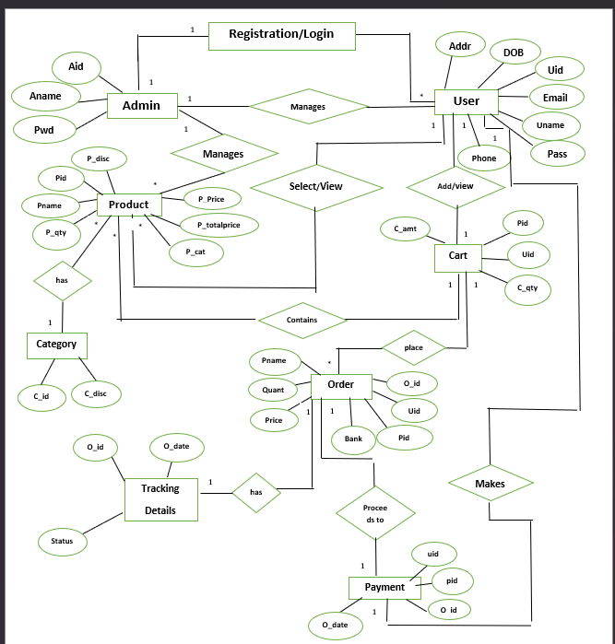

Data Dictionary:

Customer:

|  |  |  |  |  |
| --- | --- | --- | --- | --- |
| Sr . no | Field Name | Data Type | Size | Constraint |
| 1 | email | Varchar | 50 | Primary key |
| 2 | name | text | 30 | Not null |
| 3 | Password | text | 20 | Unique |
| 4 | Address | text | 30 | Not null |
| 5 | phone | text | 12 | Not null |

Product:

|  |  |  |  |  |
| --- | --- | --- | --- | --- |
| Sr . no | Field Name | Data Type | Size | Constraint |
| 1 | Product_id | Int | 25 | Primary key |
| 2 | Prod_desc | Text | 30 | Not null |
| 3 | Rate | Float | 30 | Not null |
| 4 | disc | Float | 30 | Not null |
|  | Cat_id | Int | 30 | Foreign key |

Admin:

|  |  |  |  |  |
| --- | --- | --- | --- | --- |
| Sr . no | Field Name | Data Type | Size | Constraint |
| 1 | admin_id | Int | 10 | Primary key |
| 2 | Admin_name | text | 50 | Not null |
| 2 | password | Varchar | 10 | Not null |

Category:

|  |  |  |  |  |
| --- | --- | --- | --- | --- |
| Sr . no | Field Name | Data Type | Size | Constraint |
| 1 | Cat_id | Int | 10 | Primary key |
| 2 | Cat_desc | text | 20 | Not null |

Order:

|  |  |  |  |  |
| --- | --- | --- | --- | --- |
| Sr . no | Field Name | Data Type | Size | Constraint |
| 1 | ord_id | Int | 25 | Primary key |
| 2 | ord_date | Int | 30 | Not null |
| 3 | Total | Float | 50 | Not null |
| 4 | Card_no | text | 30 | Not null |
| 5 | Processed_yn | Varchar | 30 | Not null |
| 6 | Bank_name | text | 30 | Not null |
| 7 | email | Varchar | 30 | Foreign key |

Order_details:

|  |  |  |  |  |
| --- | --- | --- | --- | --- |
| Sr . no | Field Name | Data Type | Size | Constraint |
| 1 | ord_id | Int | 25 | Foreign key |
| 2 | Prod_id | Int | 30 | Foreign key |
| 3 | qty | float | 20 | Not null |

**SYSTEM DESIGN:**

Use Case Diagram:

**Admin**

**User**

Class Diagram:-

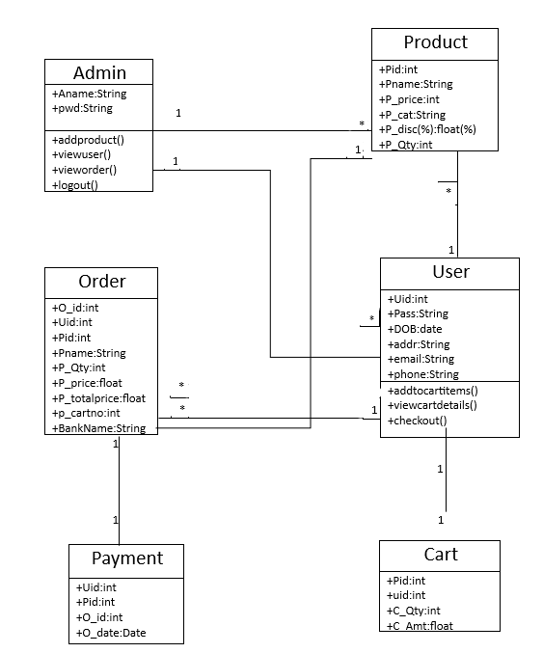

Activity Diagram:

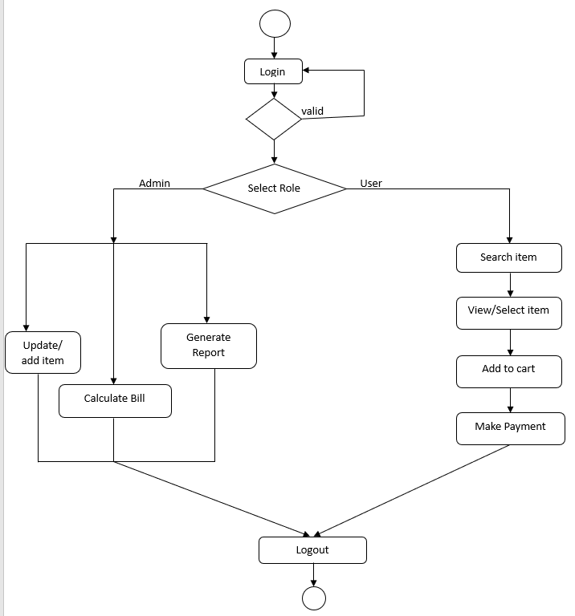

Sequence Diagram:

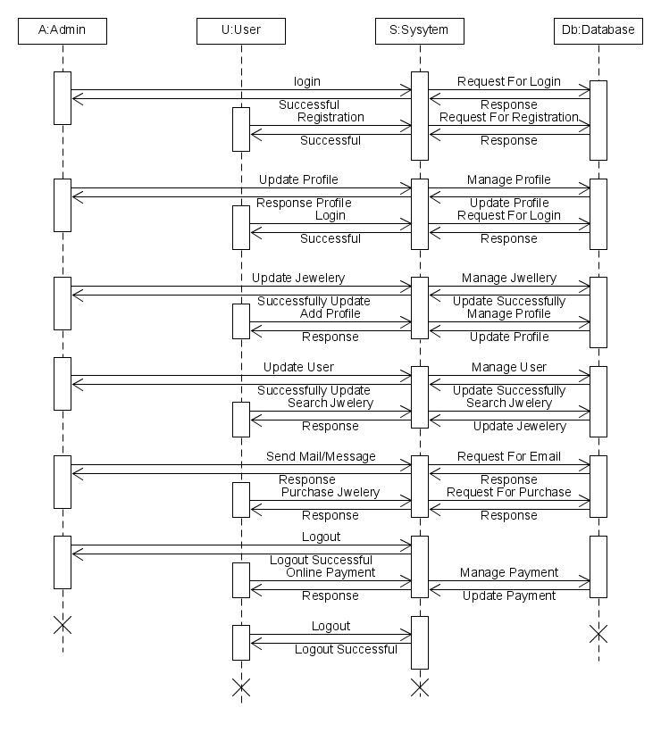

Collaboration Diagram:

**P:Payment**

**5.1 Proceeds**

**4.1 Manage_Order**

C:Cart

**O:Order**

**3.1 Add_to_Cart**

**P:Product**

**U:User**

**2.1 Search_Product**

2.2 View_Product

**2.2 View_Prodcut**

**1.1 Manage Product**

**A:Admin**

Deployment Diagram**:**   **HTTP**   **HTTP**

**Client 1**

**Online Jewellery System**

**Web Server**

**HTTP**

**Client 2**

**LAN**

**Client 3**

**Database Server**

Component Diagram:

**USER MANUAL:**

**a) Operational Instructions:-**

**Steps**:

1.First user can see the home page.

2.Then the user can see all the collection with the help of ‘category’ menu.

3.If the user wants to purchase any item, then user should register then user can login into the system.

4.In the search menu the user can see a variety of items and purchases.

5.After login, the user gets his own account. In that user can purchase the item.

**b) Input Screens: -**

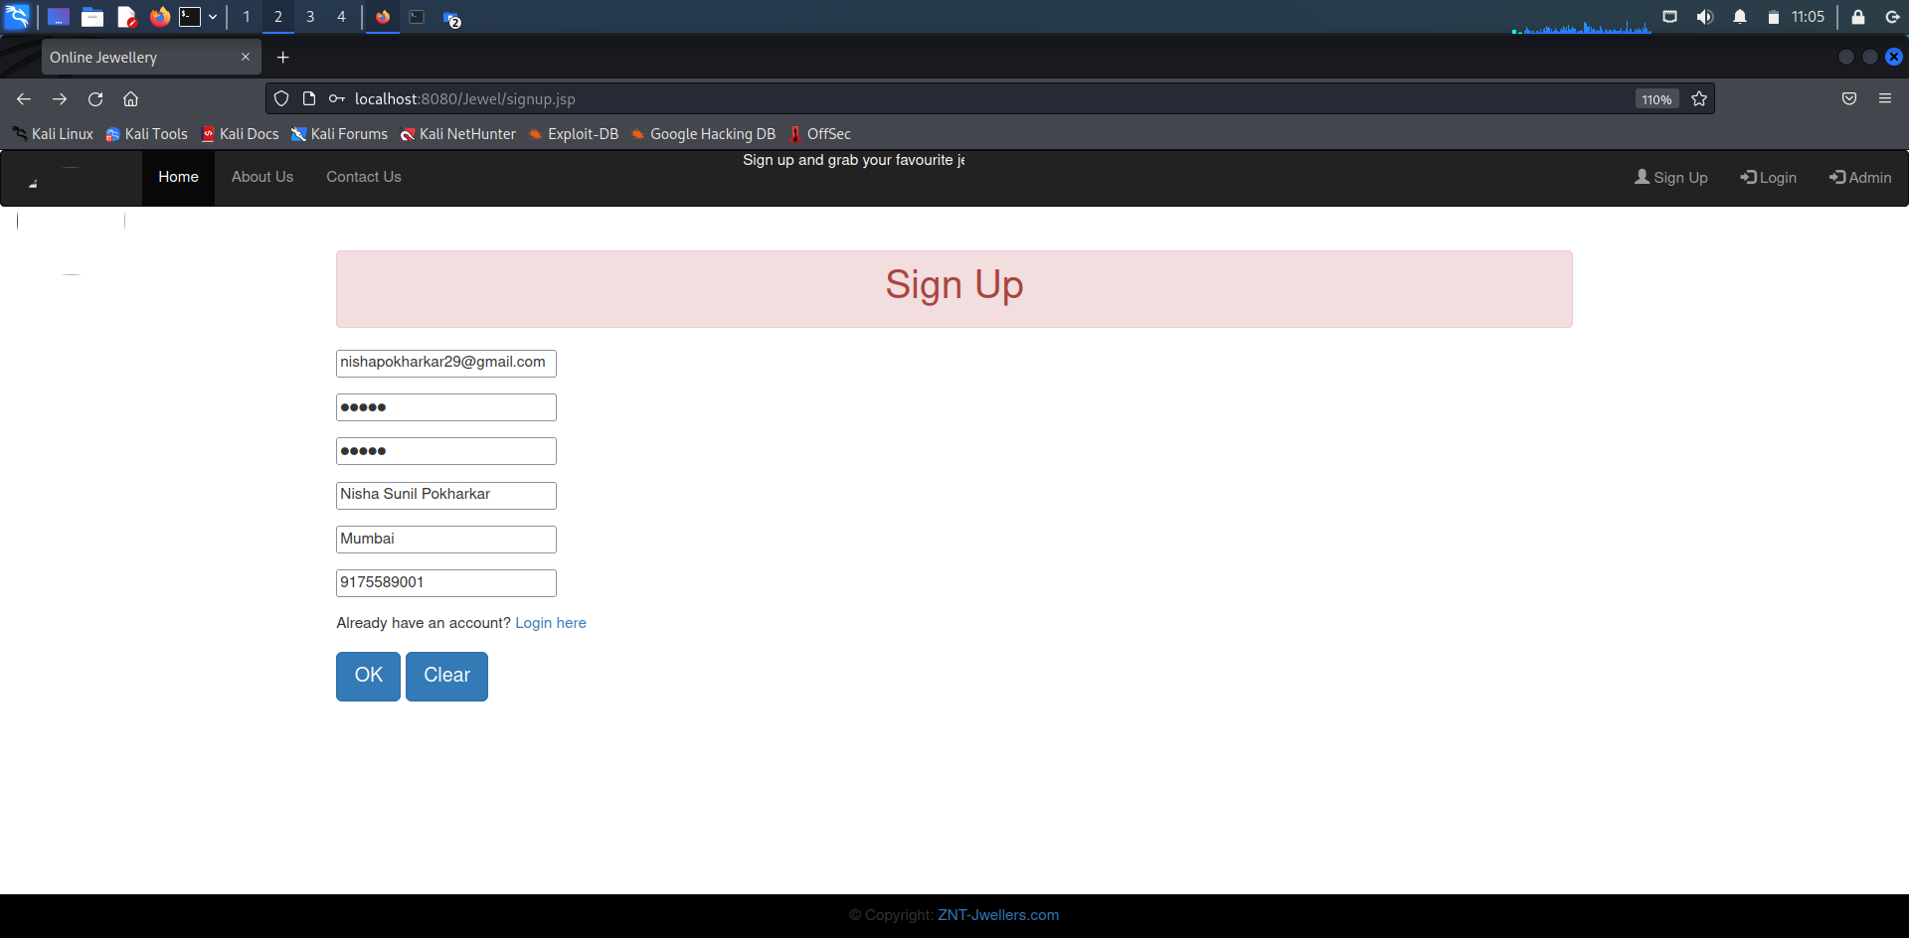

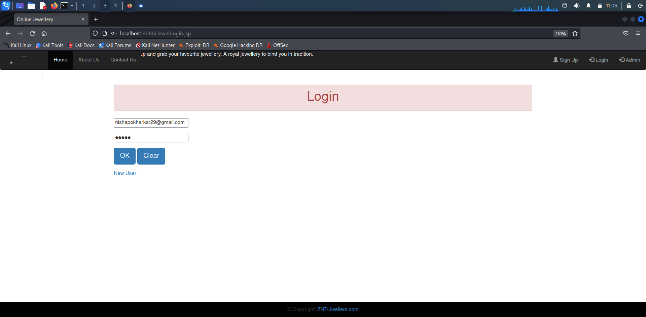

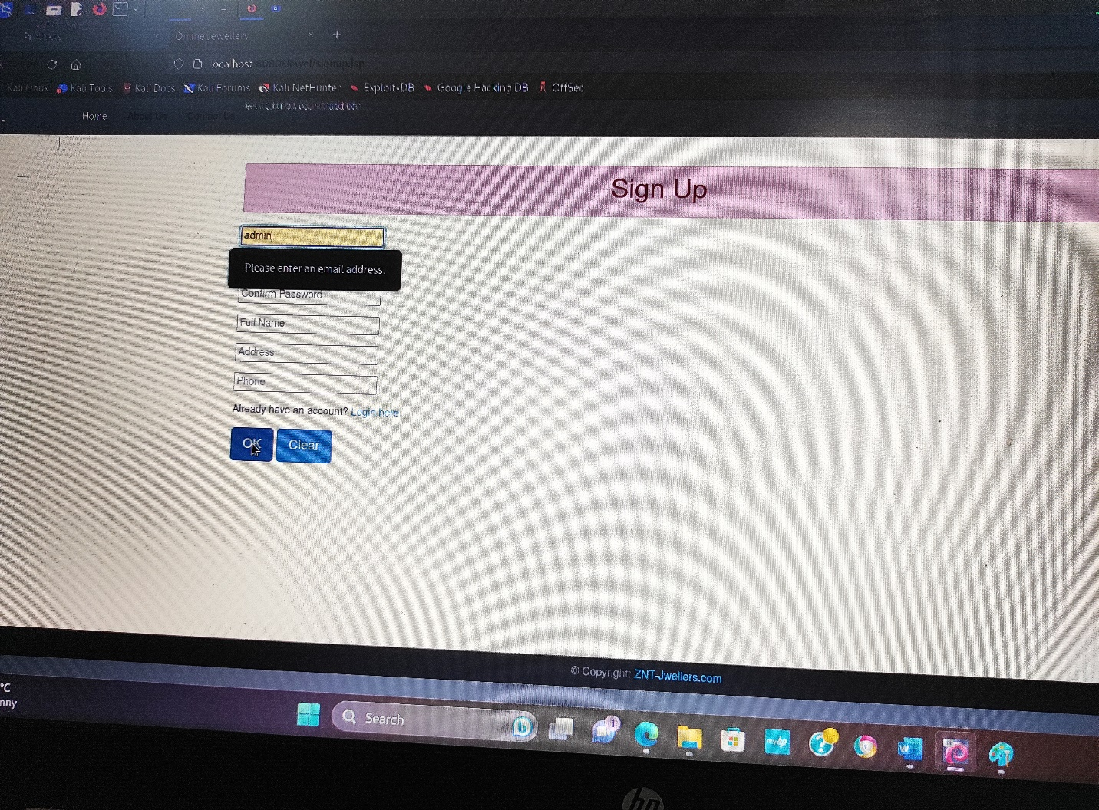

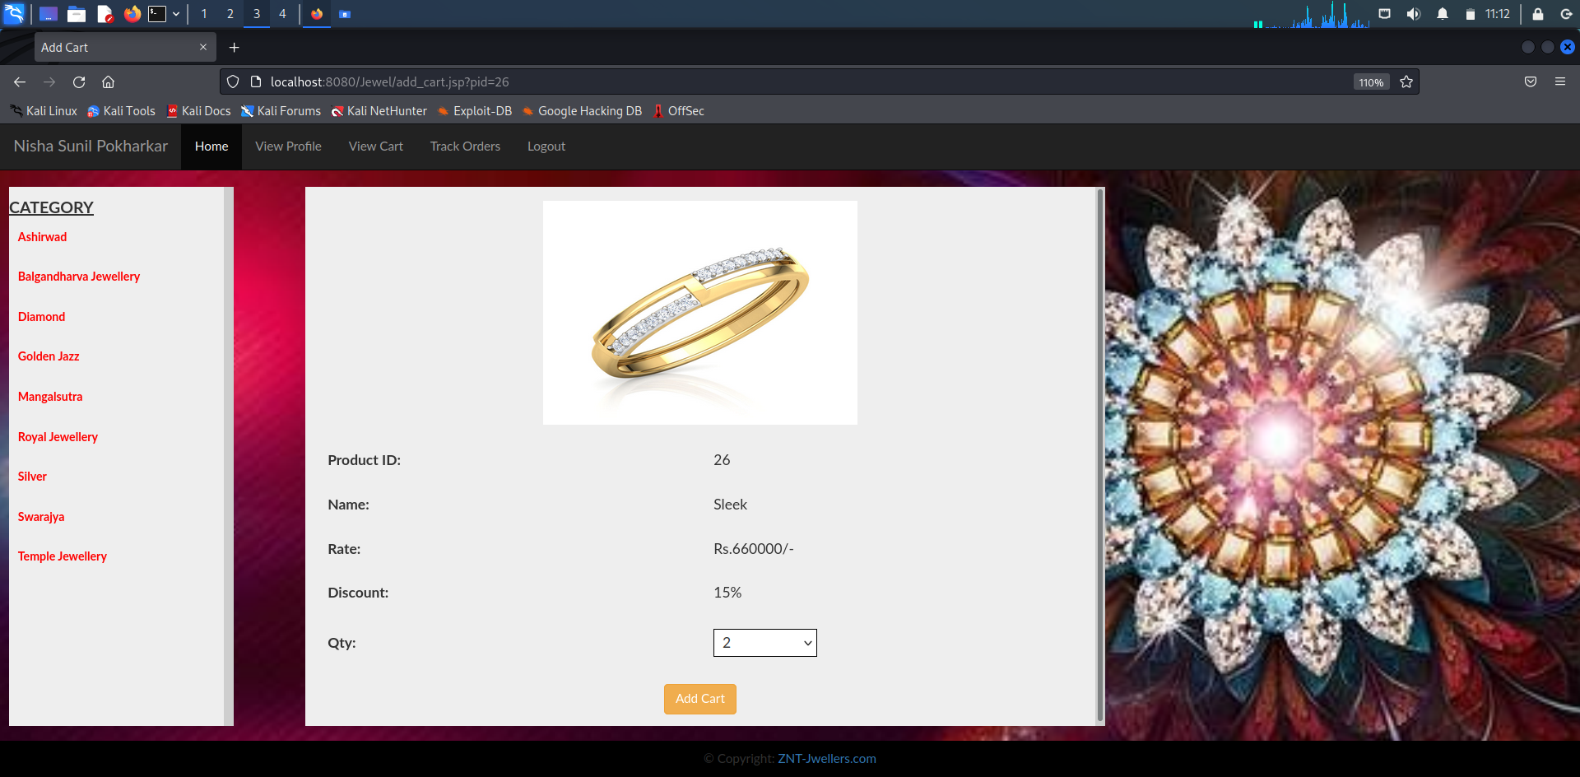

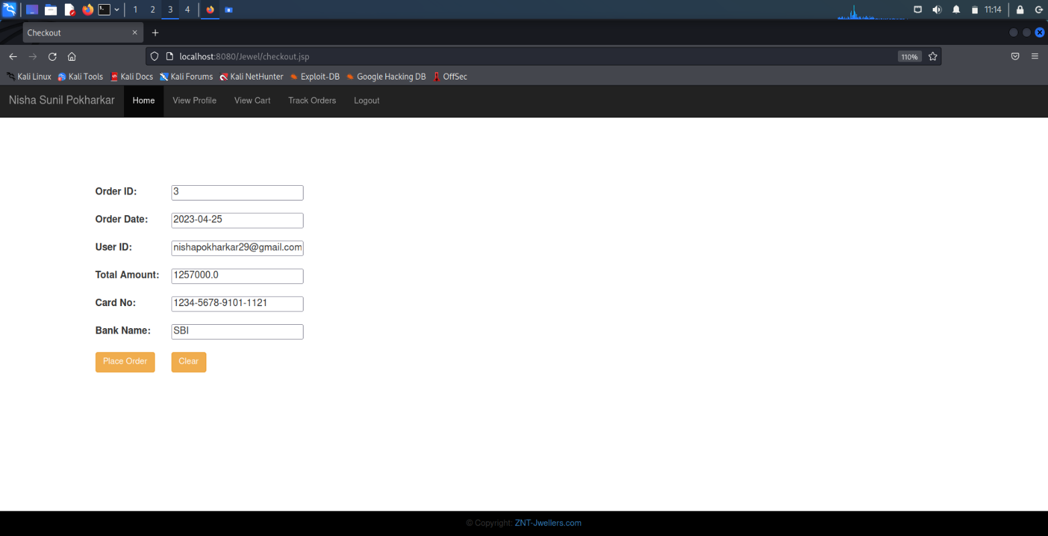

**c)Output Screens: -**

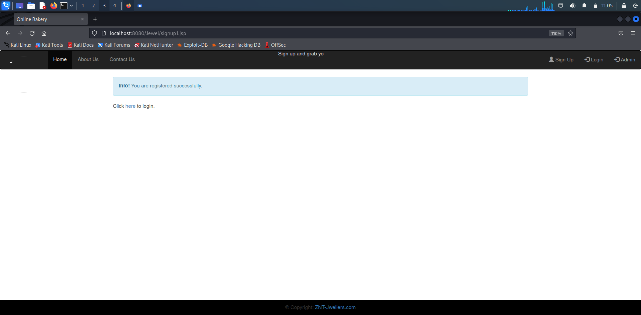

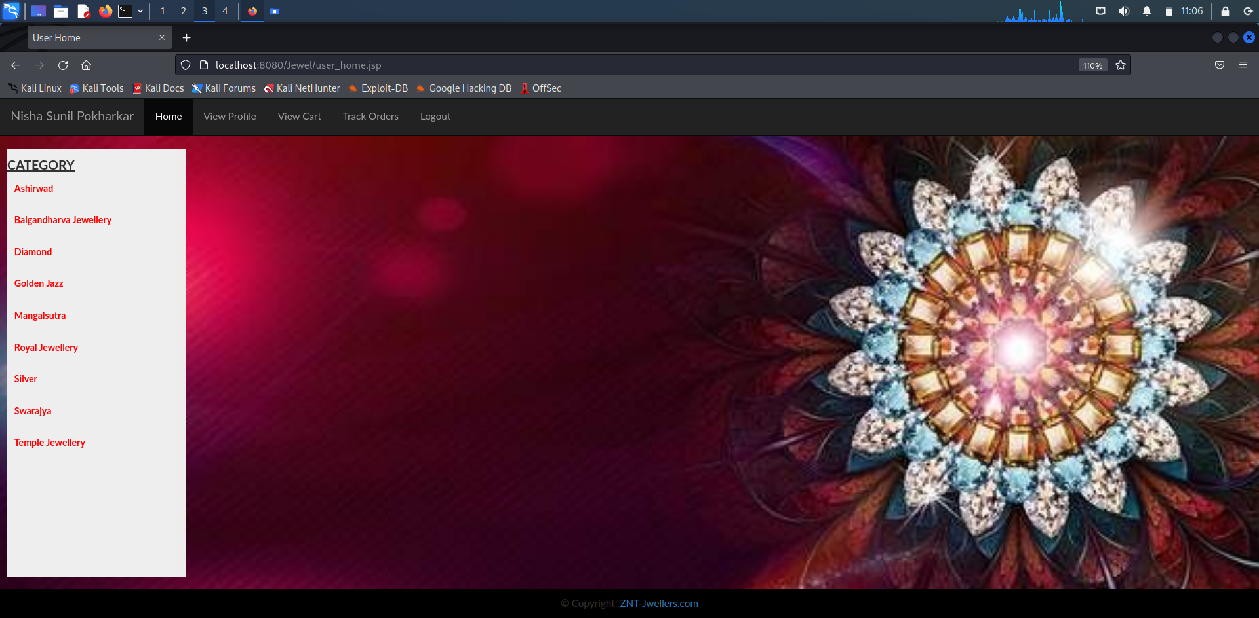

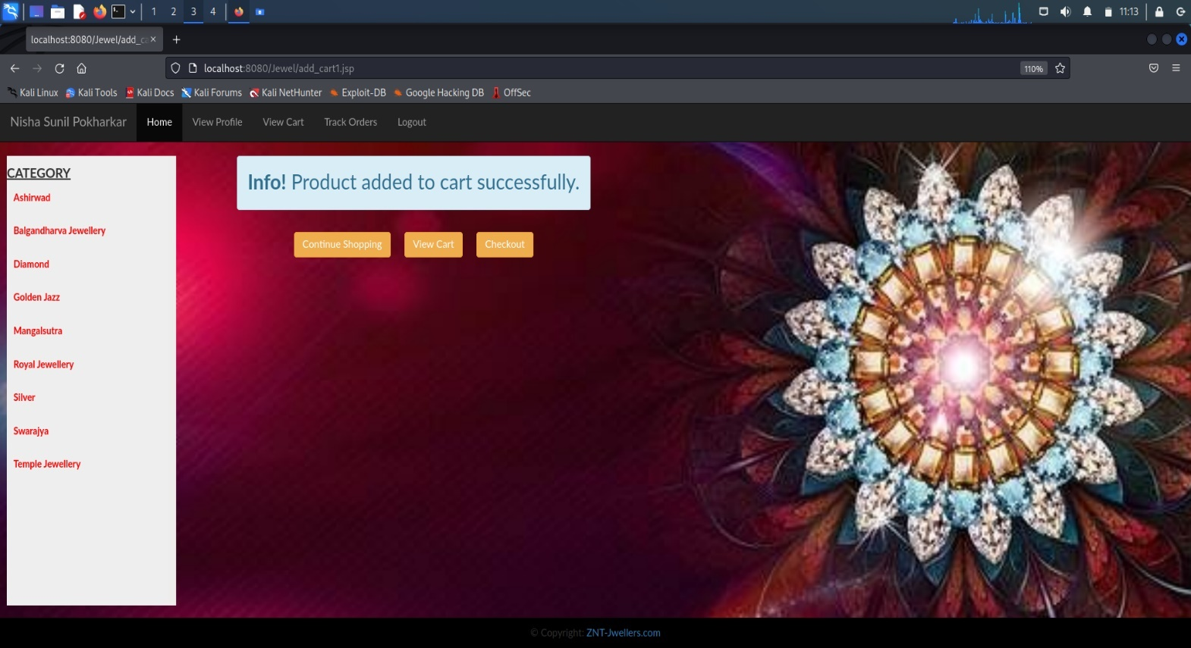

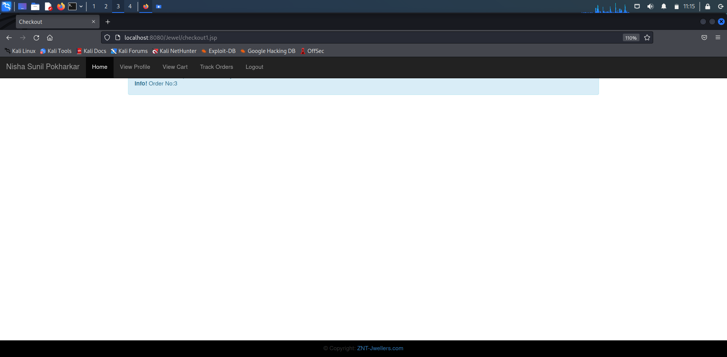

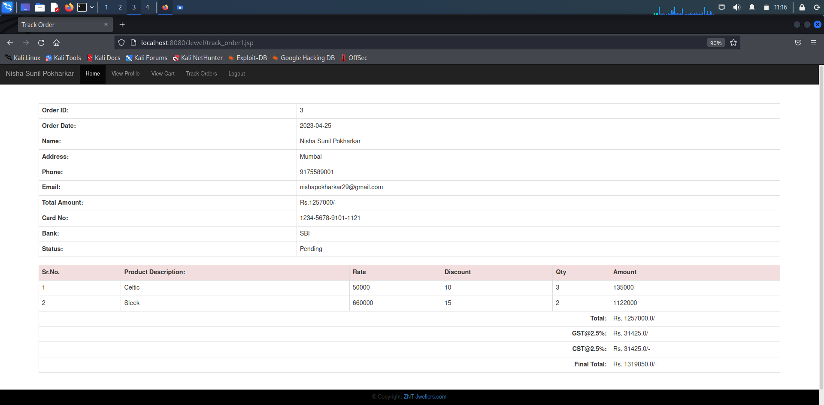

**d)Report: -**

**Customer :**

Home page

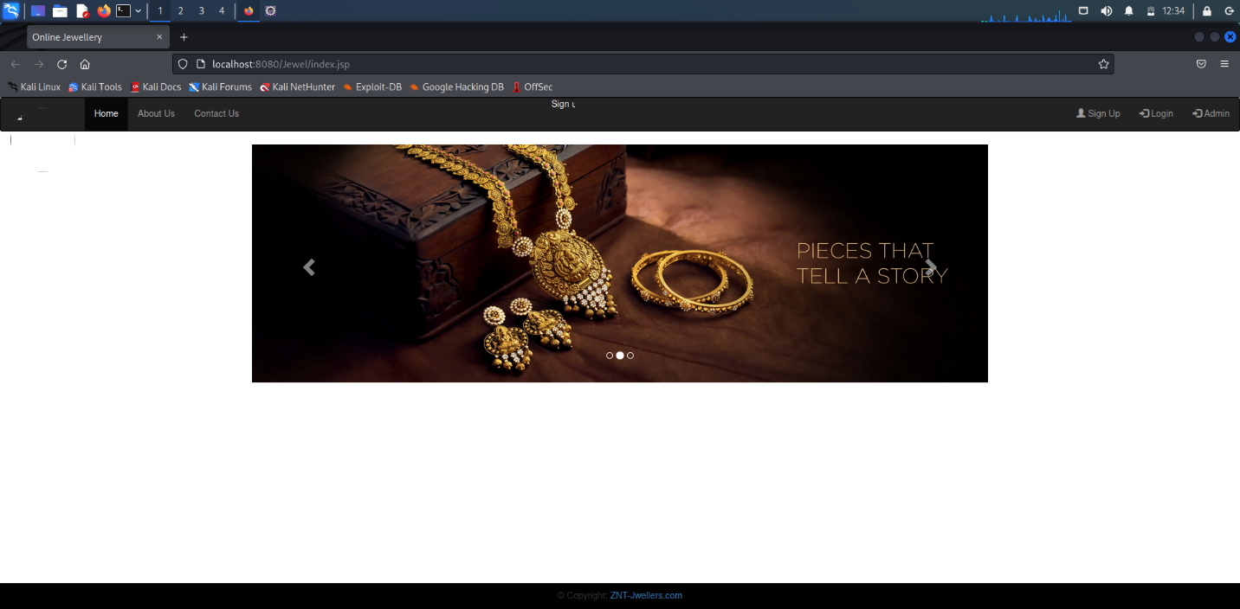

Profile:

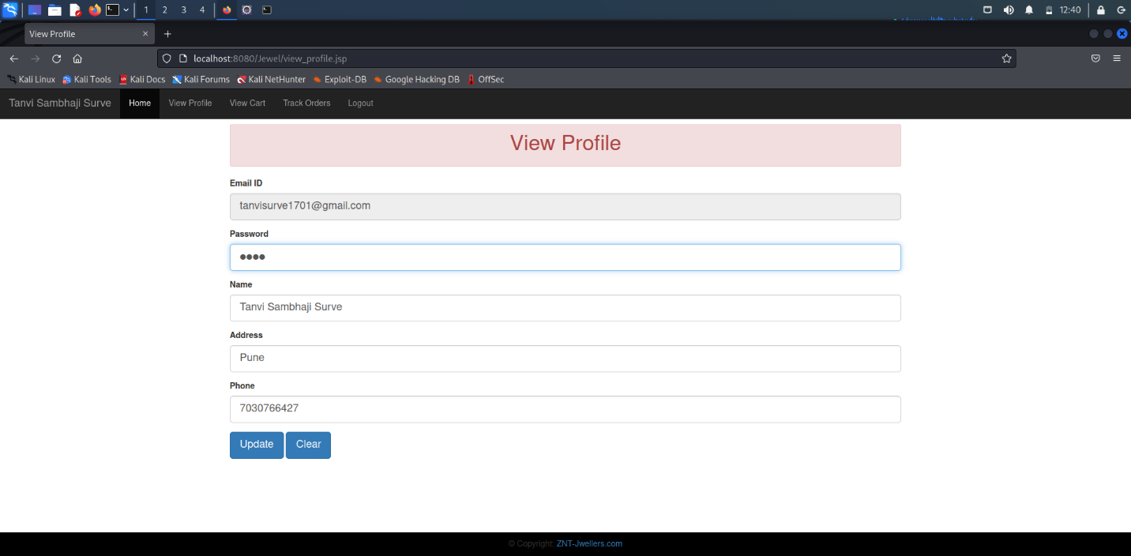

Orders:

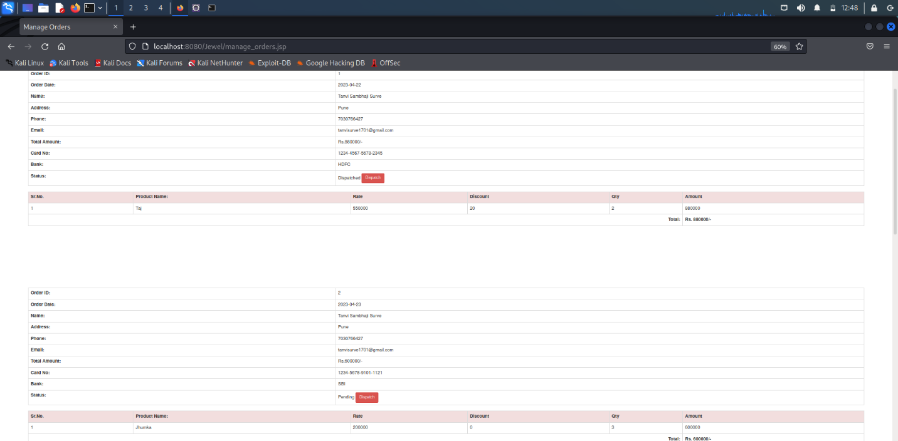

View Order:

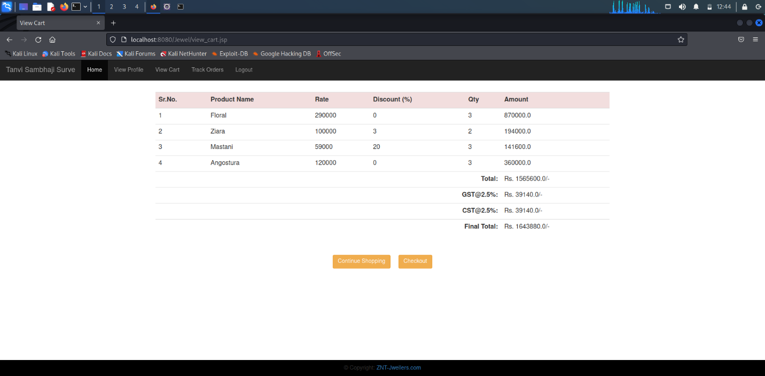

Contact us:

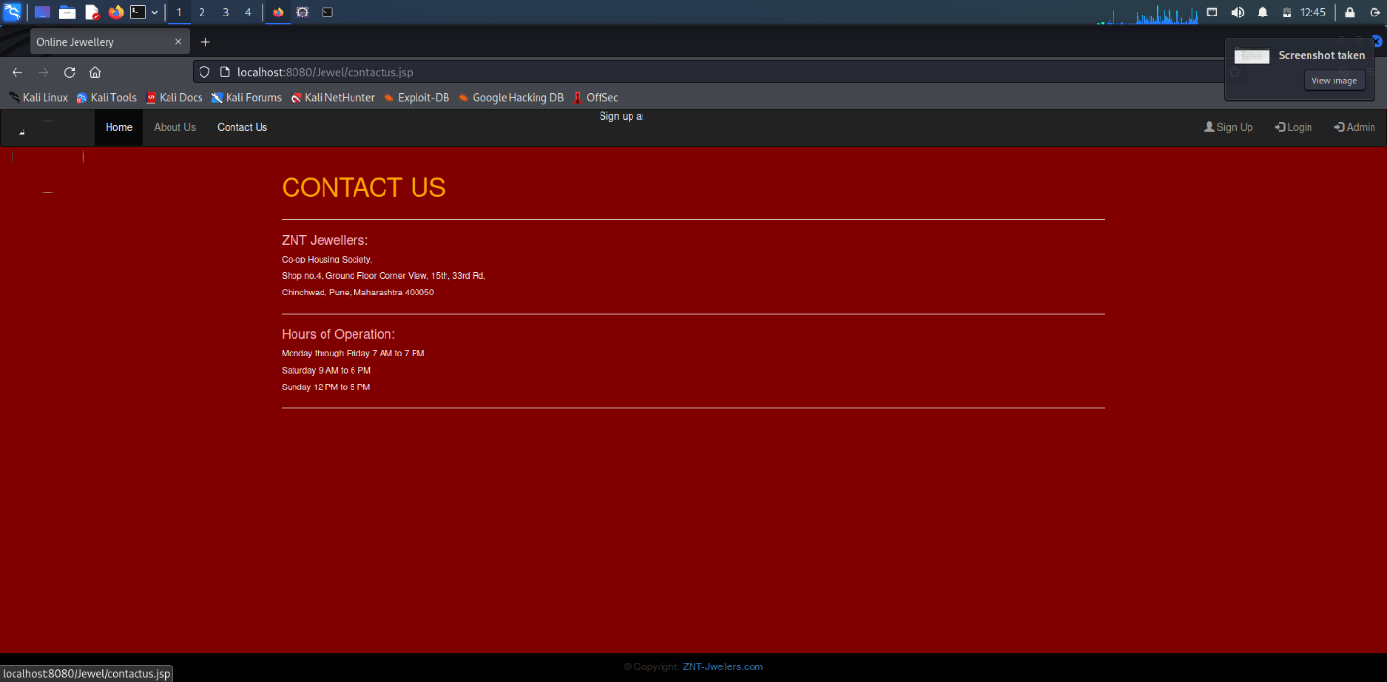

Edit Profile:

About us:

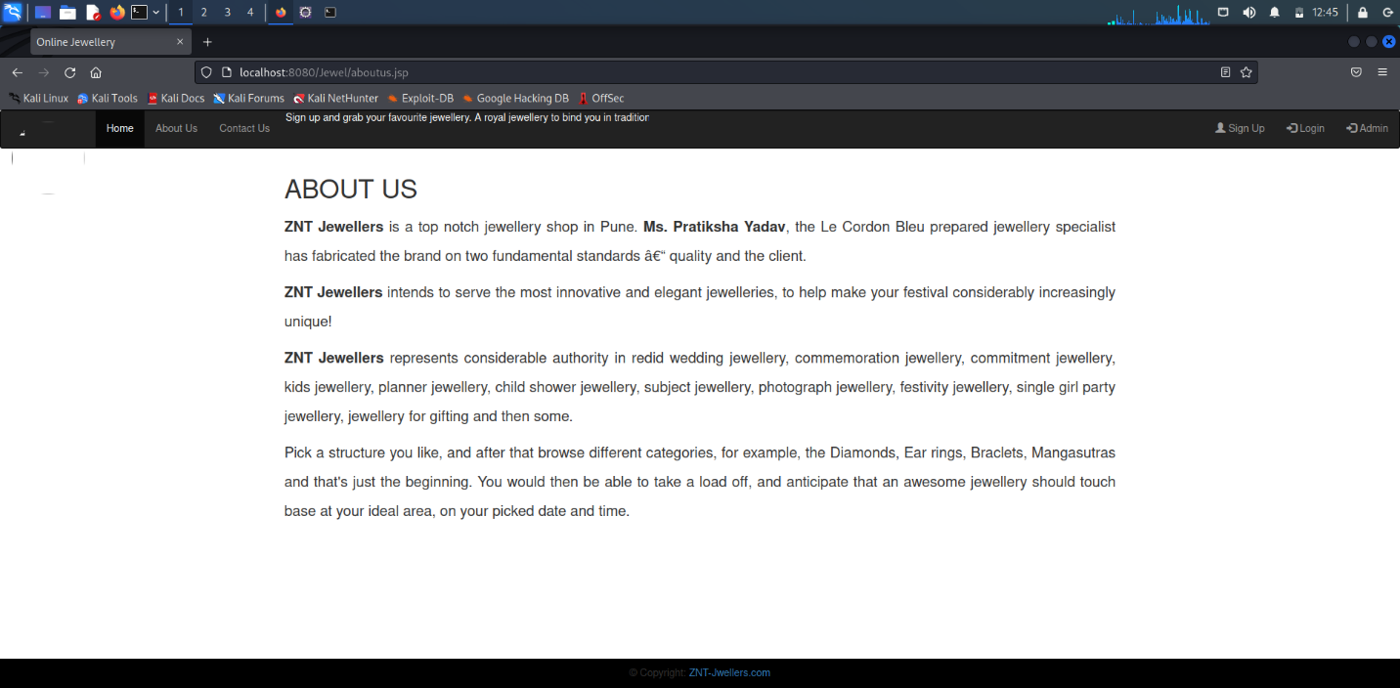

**Admin:**

Dashboard

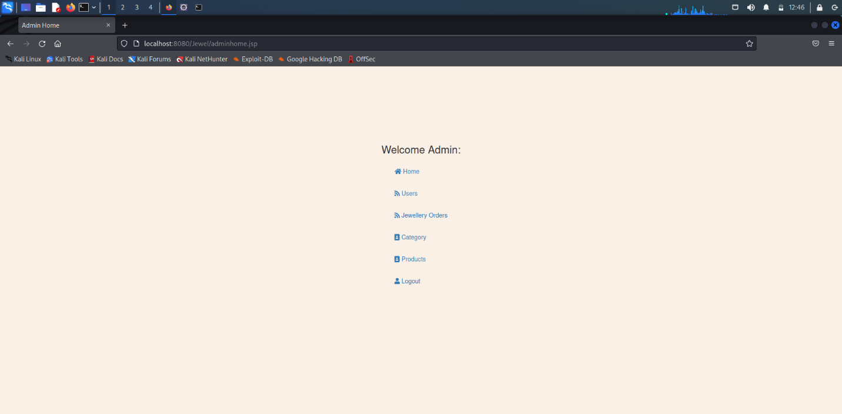

Users:

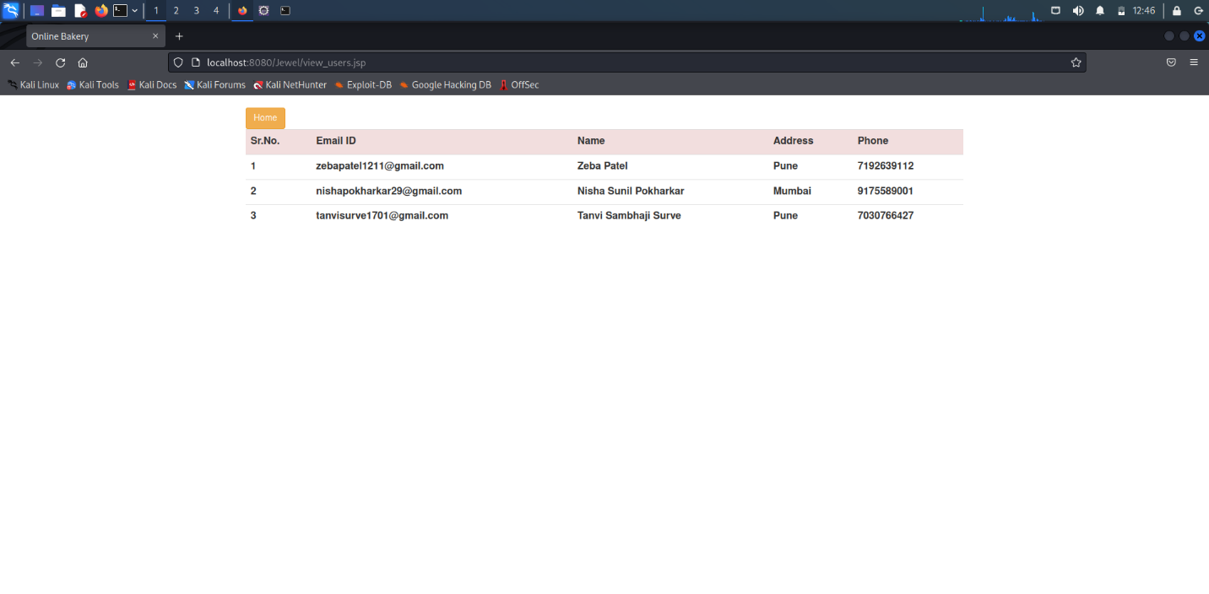

Jewellery Orders:



Category:

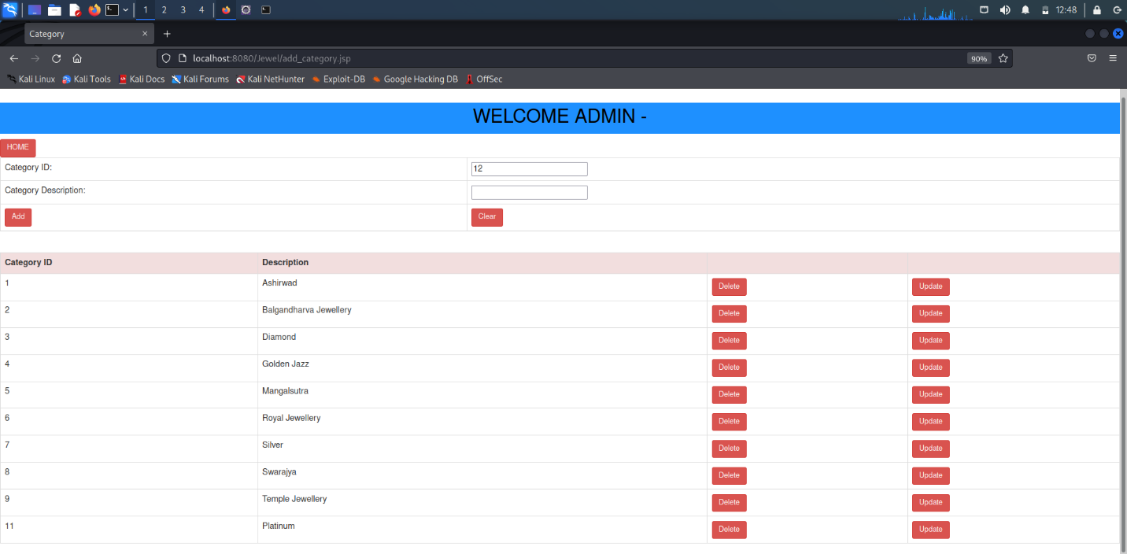

Products:

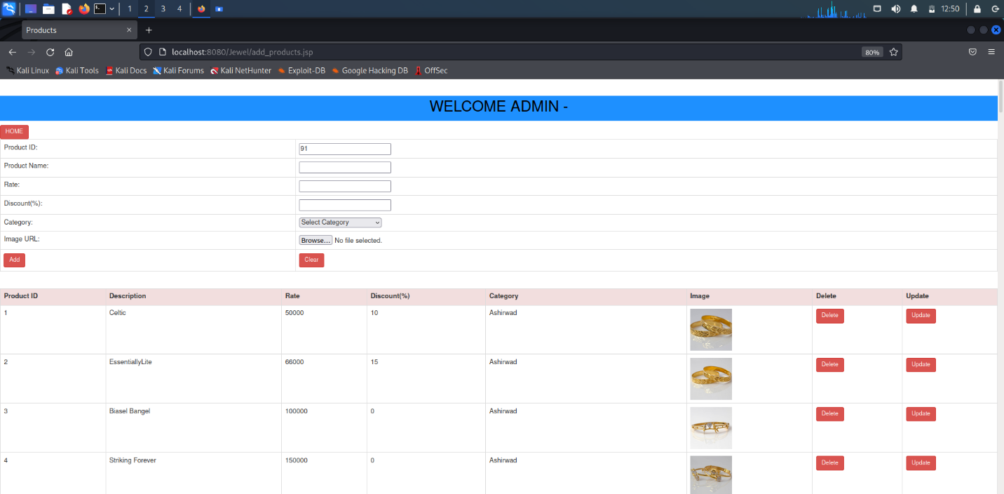

**5. Testing**

1. Testing techniques used:
2. Functional Testing: This involves testing the various functionalities of the online jewelry system, such as registration, login, browsing, searching, adding items to the cart, making a purchase, and checking out.
3. Usability Testing: This involves testing the ease of use and user-friendliness of the online jewelry system. This could involve testing the navigation, layout, design, and overall user experience of the system.
4. Performance Testing: This involves testing the speed, scalability, and stability of the online jewelry system.
5. Security Testing: This involves testing the security measures in place to protect sensitive user information and transactions. This could involve testing the authentication and authorization mechanisms.
6. Compatibility Testing: This involves testing the compatibility of the online jewelry system with different browsers, operating systems, and devices.
7. Test Cases:

|  |  |  |  |  |  |
| --- | --- | --- | --- | --- | --- |
| Test Case ID | Test Case Description | Test Data | Expected Result | Actual Result | Pass/Fail |
| TC001 | User Registration | Name: Tanvi Surve  E-mail- [tanvisurve1701@gmail.com](mailto:tanvisurve1701@gmail.com)  Password: Tanvi | User successfully registered | User successfully registered | Pass |
| TC002 | User Login | Name: Tanvi Surve  E-mail- [tanvisurve1701@gmail.com](mailto:tanvisurve1701@gmail.com)  Password: Tanvi | User successfully logged in. | User successfully logged in. | Pass |
| TC003 | View Product Category | N/A | Product category  displayed | Product category  displayed | Pass |
| TC004 | Search Product | Keyword: ”Temple Jewellery” | Relevant products displayed | Relevant Products displayed | Pass |
| TC005 | Add product to cart | Product: “Temple Jewellery”  Quantity: 2 | Product added to cart | Product added to cart | Pass |
| TC006 | View Cart | N/A | Cart displayed with added product | Cart displayed with added product | Pass |
| TC007 | Update Cart | Product: “Temple Jewellery”, New  Quantity: 1 | Cart updated with new quantity | Cart updated with new quantity | Pass |
| TC008 | Checkout | Billing and Shipping information: Name, Address and Payment Type. | Order successfully confirmed. | Order successfully confirmed. | Pass |
| TC009 | Online Payment | Click on the “Checkout" button.  . Enter valid payment details. Click on "Place Order" button. | Payment is successfully processed, and order confirmation is displayed and placed. | Payment is successfully processed, and order confirmation is displayed and placed. | Pass |
| TC010 | Track Order | Click on “Track Order” button. | Order status and shipping details are displayed. | Order status and shipping details are displayed. | Pass |
| TC011 | Logout | Click on “Logout” button. | User is successfully logged out and directed to the homepage or welcome page. | User is successfully logged out and directed to the homepage or welcome page. | Pass |

**Future Enhancement:**

* Add more jewellery types in website.
* Try to all user contact with phone call.
* Add more features in site future.
* We will add online payment in future.

**Conclusion:**

The system as we have seen is very useful, reliable, and user-friendly. The system can be accessed only by reliable user having their own passwords. Thus the information cannot be leaked out & can be managed properly.

This software reduces manual errors to a great extent.

**Bibliography**:

Websites: -

* www.shine.com
* www.tbz.com
* www.code-project.com
* www.jaweryandco.com
* [www.tutorialpoint.com](http://www.tutorialpoint.com)